Model Tree Structures

MongoDB allows various ways to use tree data structures to model large hierarchical or nested data relationships

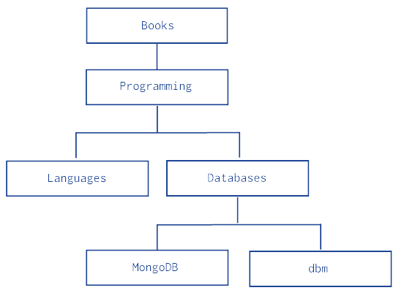

Model Tree Structures with Parent References
Presents a data model that organizes documents in a tree-like structure by storing references to “parent” nodes in “child” nodes.

The following example models the tree using Parent References, storing the reference to the parent category in the field parent:

db.categories.insert( { _id: "MongoDB", parent: "Databases" } )
db.categories.insert( { _id: "dbm", parent: "Databases" } )
db.categories.insert( { _id: "Databases", parent: "Programming" } )
db.categories.insert( { _id: "Languages", parent: "Programming" } )
db.categories.insert( { _id: "Programming", parent: "Books" } )
db.categories.insert( { _id: "Books", parent: null } )

The query to retrieve the parent of a node is fast and straightforward:

db.categories.findOne( { _id: "MongoDB" } ).parent

You can query by the parent field to find its immediate children nodes:

db.categories.find( { parent: "Databases" } )
Model Tree Structures with Child References
Presents a data model that organizes documents in a tree-like structure by storing references to “child” nodes in “parent” nodes.

The following example models the tree using Child References, storing the reference to the node’s children in the field children:

db.categories.insert( { _id: "MongoDB", children: [] } )
db.categories.insert( { _id: "dbm", children: [] } )
db.categories.insert( { _id: "Databases", children: [ "MongoDB", "dbm" ] } )
db.categories.insert( { _id: "Languages", children: [] } )
db.categories.insert( { _id: "Programming", children: [ "Databases", "Languages" ] } )
db.categories.insert( { _id: "Books", children: [ "Programming" ] } )

The query to retrieve the immediate children of a node is fast and straightforward:

db.categories.findOne( { _id: "Databases" } ).children

You can query for a node in the children field to find its parent node as well as its siblings:

db.categories.find( { children: "MongoDB" } )

The Child References pattern provides a suitable solution to tree storage as long as no operations on subtrees are necessary. This pattern may also provide a suitable solution for storing graphs where a node may have multiple parents.

Model Tree Structures with an Array of Ancestors
Presents a data model that organizes documents in a tree-like structure by storing references to “parent” nodes and an array that stores all ancestors.
The following example models the tree using Array of Ancestors. In addition to the ancestors field, these documents also store the reference to the immediate parent category in the parent field:

db.categories.insert( { _id: "MongoDB", ancestors: [ "Books", "Programming", "Databases" ], parent: "Databases" } )
db.categories.insert( { _id: "dbm", ancestors: [ "Books", "Programming", "Databases" ], parent: "Databases" } )
db.categories.insert( { _id: "Databases", ancestors: [ "Books", "Programming" ], parent: "Programming" } )
db.categories.insert( { _id: "Languages", ancestors: [ "Books", "Programming" ], parent: "Programming" } )
db.categories.insert( { _id: "Programming", ancestors: [ "Books" ], parent: "Books" } )
db.categories.insert( { _id: "Books", ancestors: [ ], parent: null } )

The query to retrieve the ancestors or path of a node is fast and straightforward:

db.categories.findOne( { _id: "MongoDB" } ).ancestors

You can query by the field ancestors to find all its descendants:

db.categories.find( { ancestors: "Programming" } )

The Array of Ancestors pattern provides a fast and efficient solution to find the descendants and the ancestors of a node by creating an index on the elements of the ancestors field. This makes Array of Ancestors a good choice for working with subtrees.

Model Tree Structures with Materialized Paths
Presents a data model that organizes documents in a tree-like structure by storing full relationship paths between documents. In addition to the tree node, each document stores the _id of the nodes ancestors or path as a string.

The following example models the tree using Materialized Paths, storing the path in the field path; the path string uses the comma , as a delimiter:

db.categories.insert( { _id: "Books", path: null } )
db.categories.insert( { _id: "Programming", path: ",Books," } )
db.categories.insert( { _id: "Databases", path: ",Books,Programming," } )
db.categories.insert( { _id: "Languages", path: ",Books,Programming," } )
db.categories.insert( { _id: "MongoDB", path: ",Books,Programming,Databases," } )
db.categories.insert( { _id: "dbm", path: ",Books,Programming,Databases," } )

You can query to retrieve the whole tree, sorting by the field path:

db.categories.find().sort( { path: 1 } )

You can use regular expressions on the path field to find the descendants of Programming:

db.categories.find( { path: /,Programming,/ } )

You can also retrieve the descendants of Books where the Books is also at the topmost level of the hierarchy:

db.categories.find( { path: /^,Books,/ } )

